**Activity: External Anatomy Lab**

**Directions:** Label the following items and identify the Order namefor each of the insects. The below terms may be used more than once.

* Types of mouthparts: Chewing, Piercing-sucking, Siphoning, Chewing-lapping, Sponging
* Types of legs: Natatorial, Saltatorial, Fossorial, Raptorial, Cursorial)
* Types of Wings: Membranous, Hemelytra, Elytra, Halteres, Leathery
* Thorax modification: Pronotum, Scutellum
* Types of larvae: Eruciform, Elateriform, Scarabaeiform, Campodeiform, Vermiform
* Types of pupae: Exarate, Obtect, Coarctate

Grasshopper (Order: **Orthoptera**)

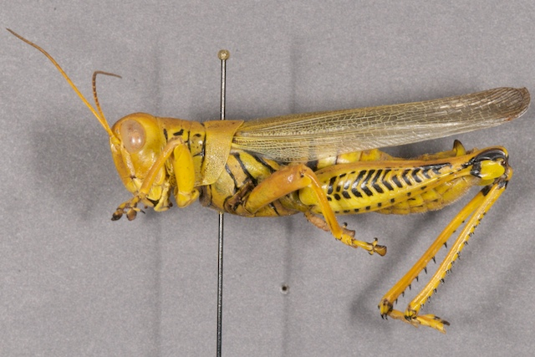

Type of Legs: **Saltatorial**

Thorax modification: **Pronotum**

Type of Wings: **Leathery**

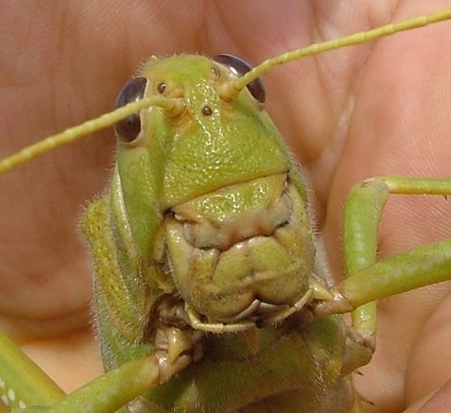

Type of Mouthparts: **Chewing**

Cockroach (Order: **Blattodea**)

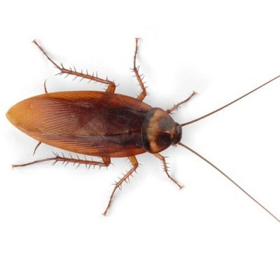

Type of Legs: **Cursorial**

Type of Wings: **Hemelytra**

Thorax modification: **Pronotum**

Type of Mouthparts: **Piercing-sucking**

Stink Bug (Order: **Coleoptera**)

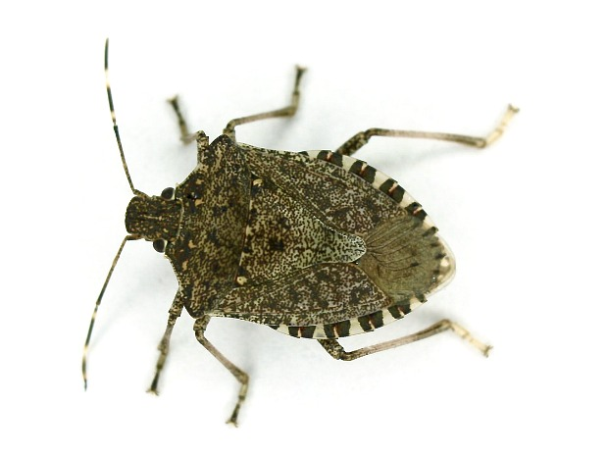 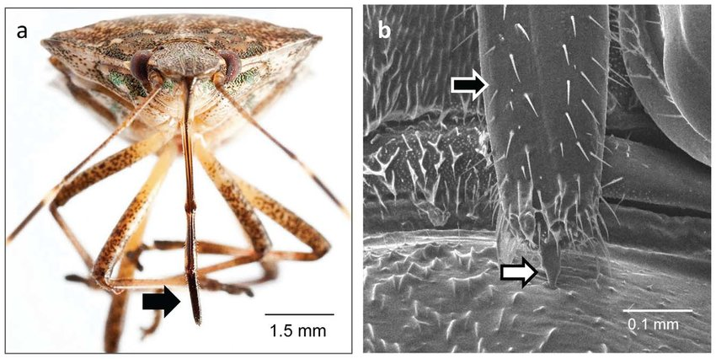

Thorax modification: **Scutella**

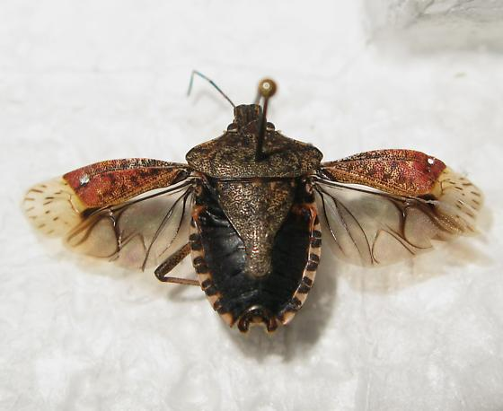

Type of Wings: **Elytra**

Diving beetle (Order: **Coleoptera**)

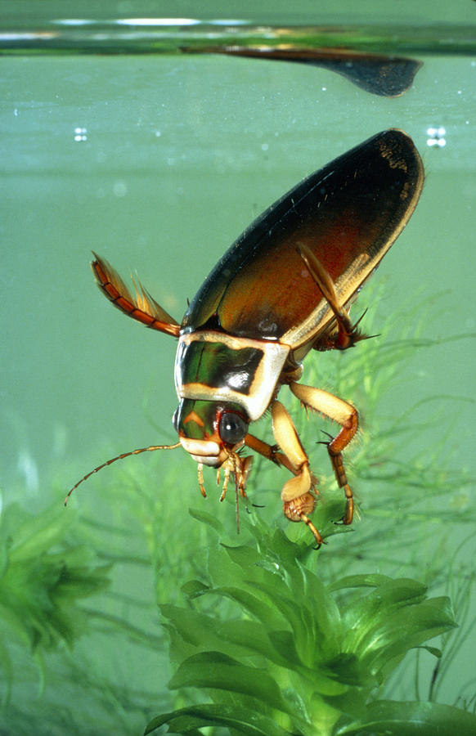

Type of Legs: **Natatorial**

House Fly (Order: **Diptera**)

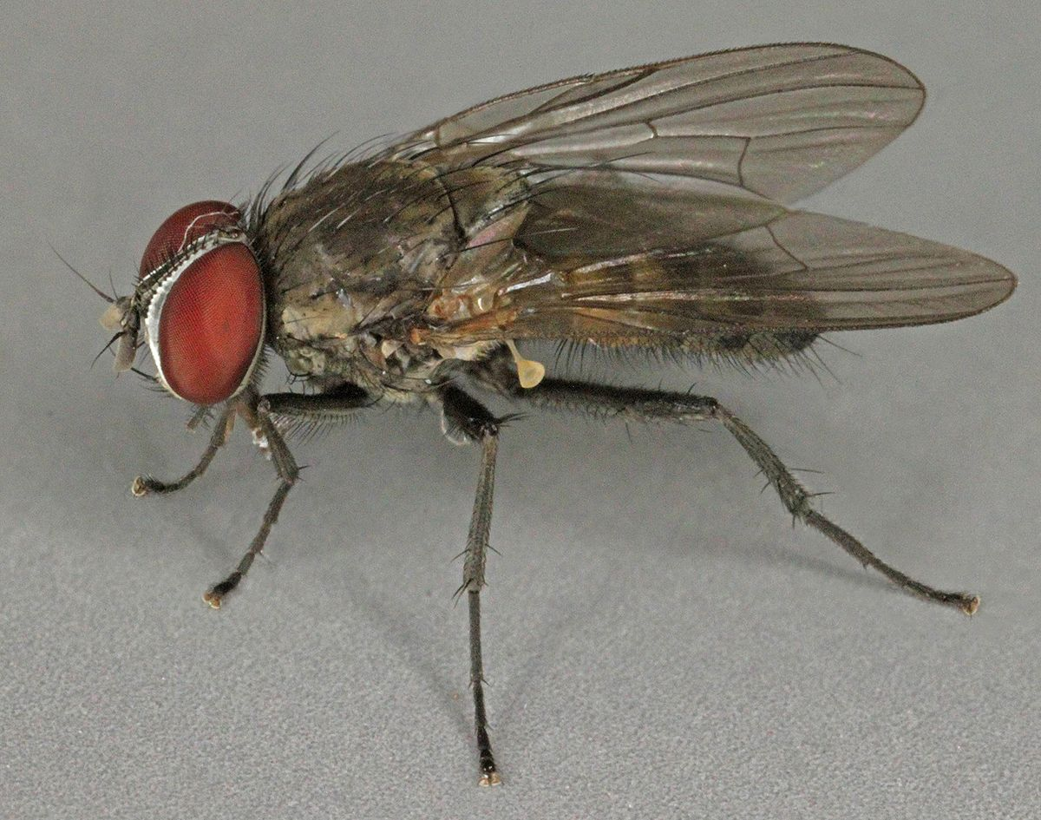

Type of Wings: **Halteres**

Moth/Bee/Fly Mouthparts

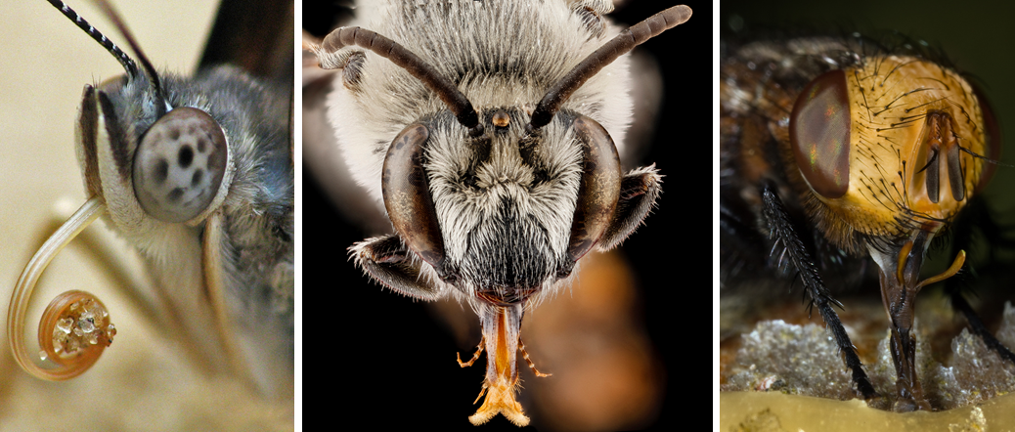

Type of Mouthparts: **Siphoning**

Type of Mouthparts: **Chewing-lapping**

Type of Mouthparts: **Sponging**

Moth (Order: **Lepidoptera**) Bee (Order: **Hymenoptera**) Fly (Order: **Diptera**)

Rhinoceros Beetle (Order: **Coleoptera**)

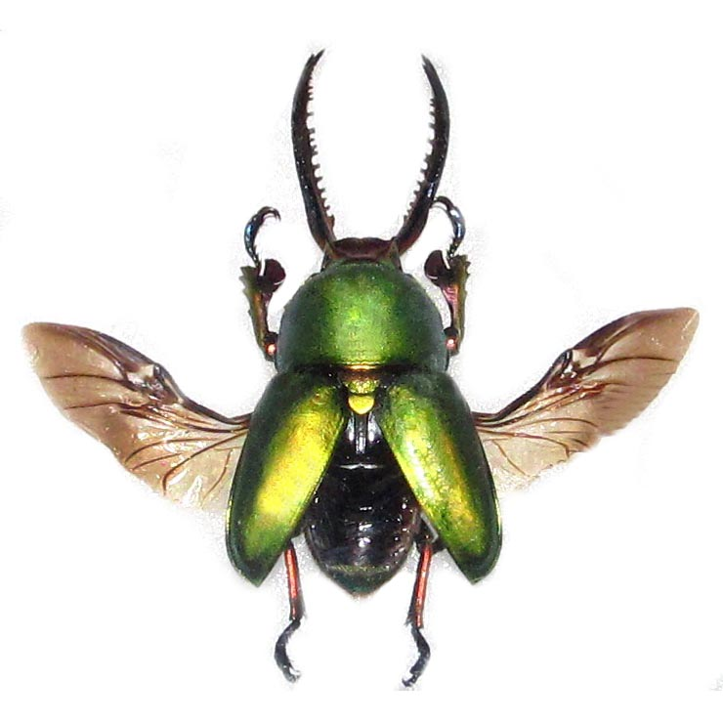

Type of Wings: **Elytra**

Mole Cricket (Order: **Orthoptera**)

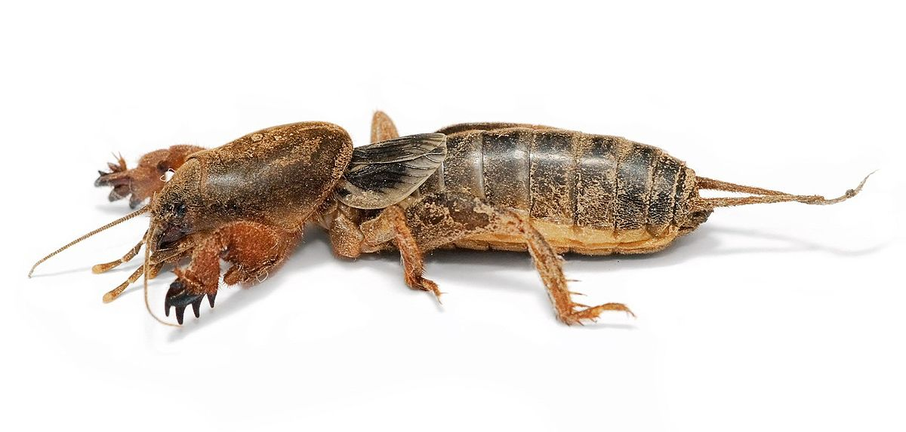

Type of Legs: **Fossorial**

Praying Mantid (Order: **Mantis**)

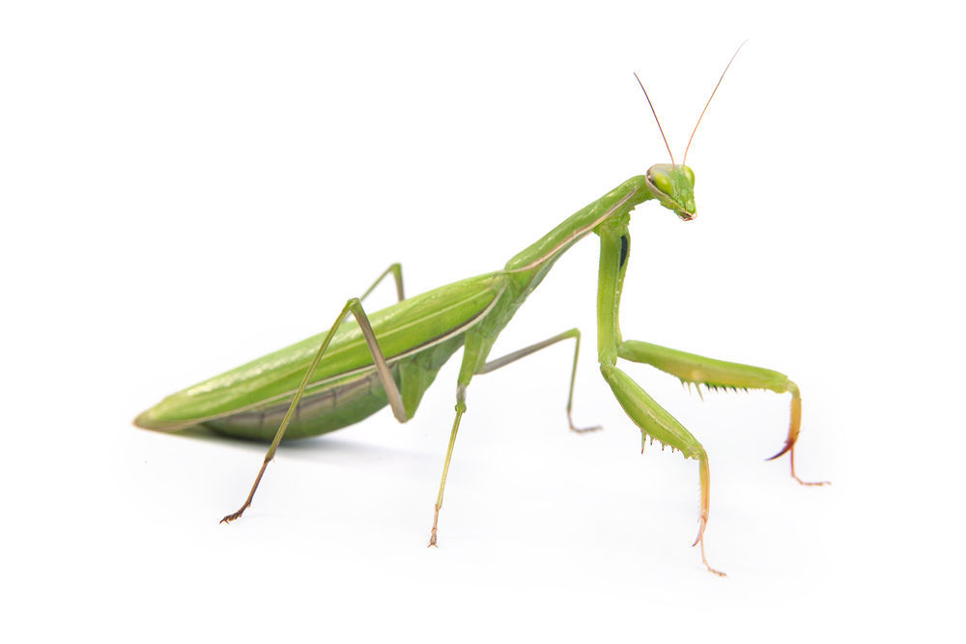

Type of Legs: **Raptorial**

Dragonfly (Order: **Odonata**)

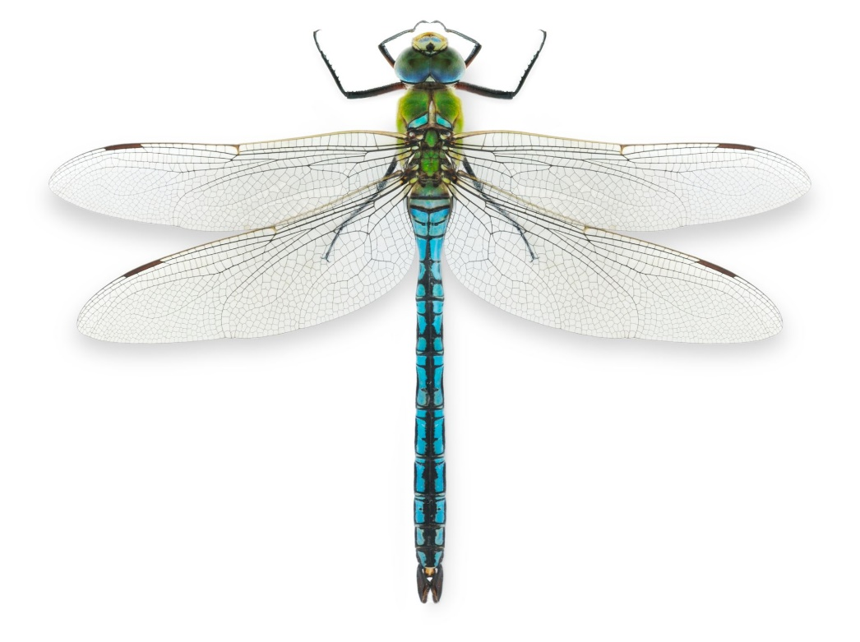

Type of Wings: **Membranous**

Click Beetle Larvae (Order: **Coleoptera**)

Type of Larvae: **Eruciform**

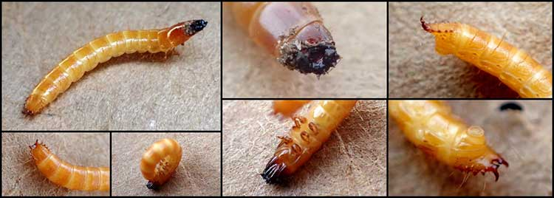

Monarch Caterpillar (Order: **Leoidoptera**)

Type of Larvae: **Eruciform**

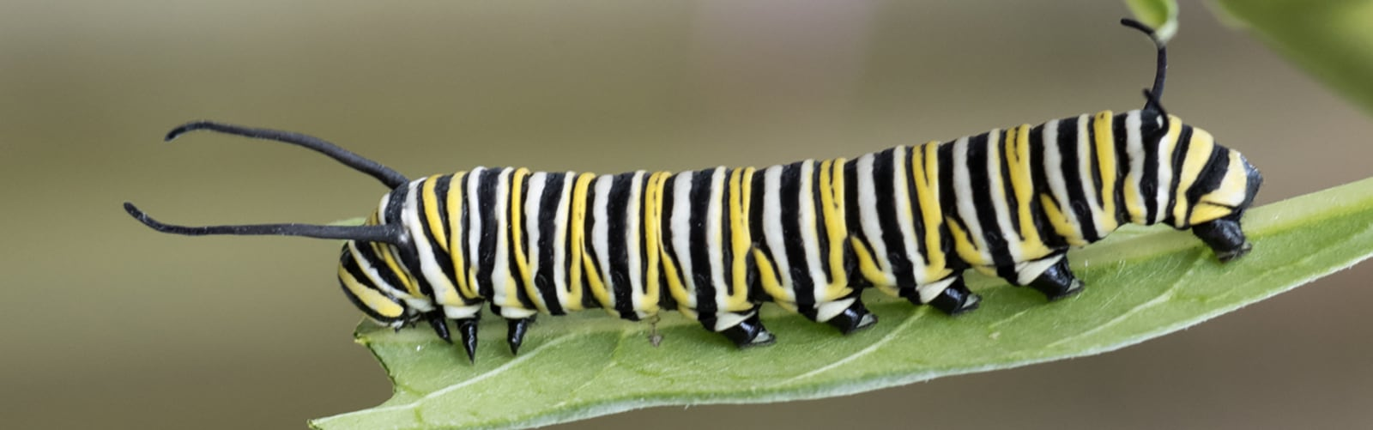

Grub (Order: **Coleoptera**)

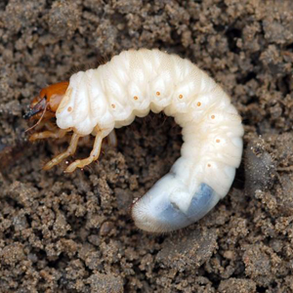

Type of Larvae: **Scarabaeiform**

House Fly Maggot (Order: **Diptera**)

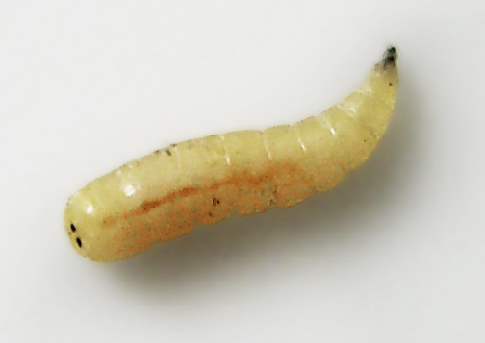

Type of Larvae: **Vermiform**

Lacewing Larvae (Order: **Neuroptera**)

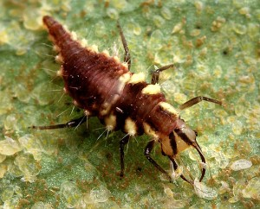

Type of Larvae: **Campodeiform**

Fruit Fly and House Fly Pupae (Order: **Diptera**)

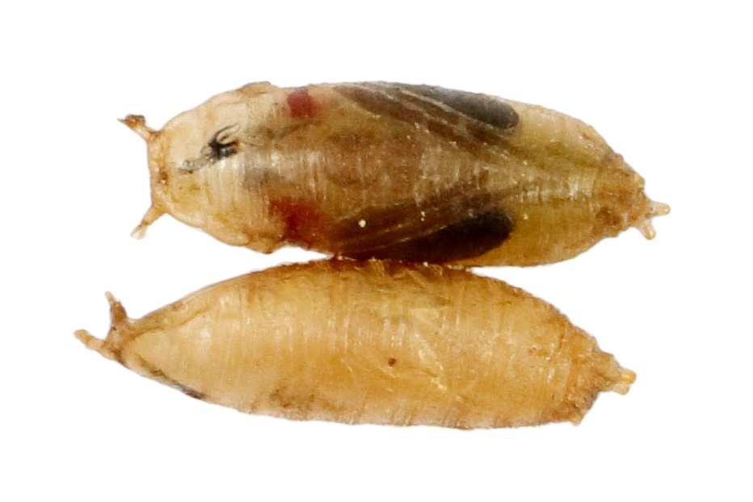 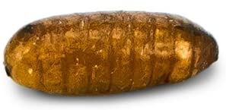

Type of Pupae: **Coarctate**

Honey Bee and Wasp Pupae (Order: **Hymenoptera**)

Type of Pupae: **Exarate**

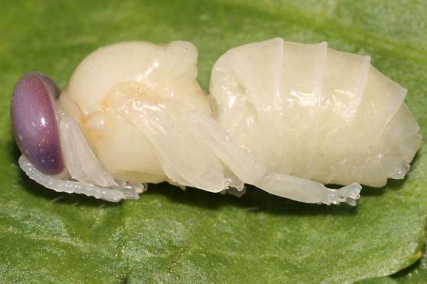 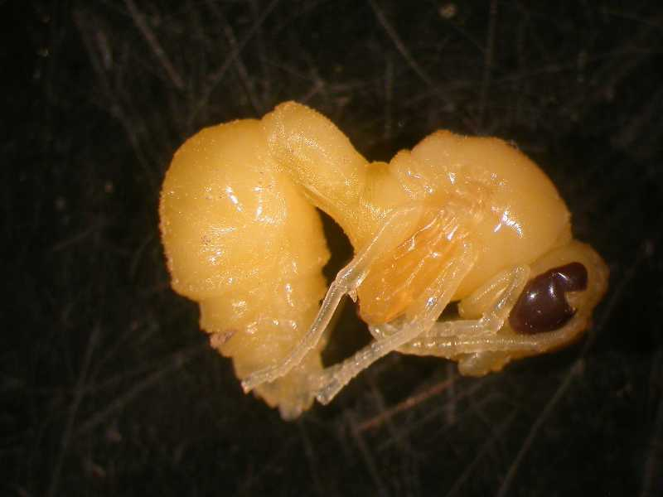

Eastern Black Swallowtail and Tobacco Hornworm Pupa (Order: **Lepidoptera**)

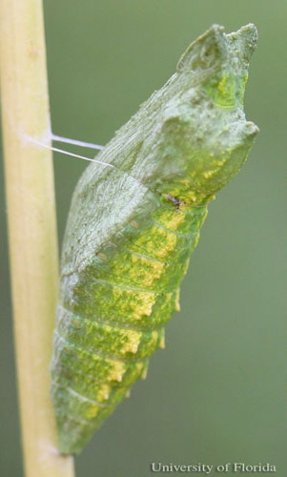 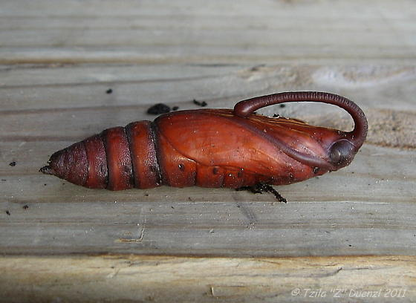

Type of Pupae: **Obtect**

Mosquito Pupa (Order: **Diptera**)

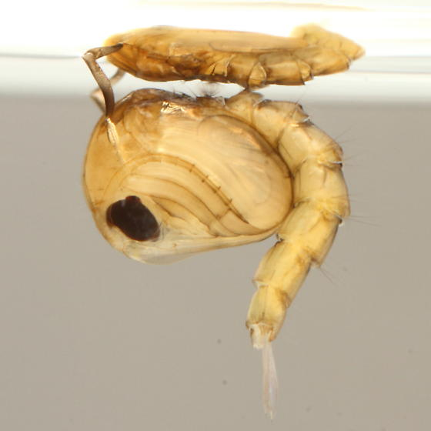

Type of Pupae: **Obtect**